**Module 8 - CloudFormation and App Services**

**CloudFormation-SNS-Assignment**

**Task 1**

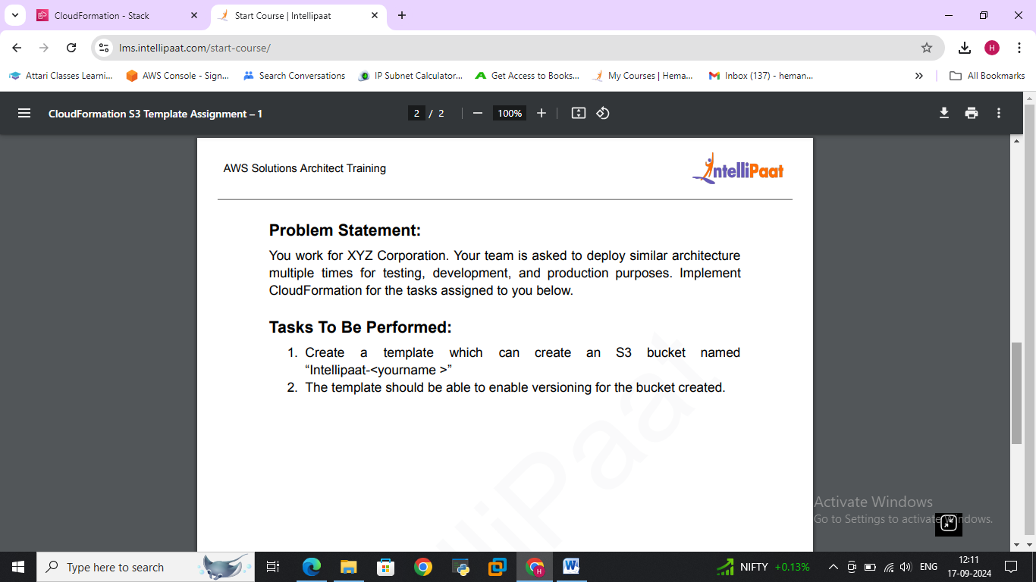

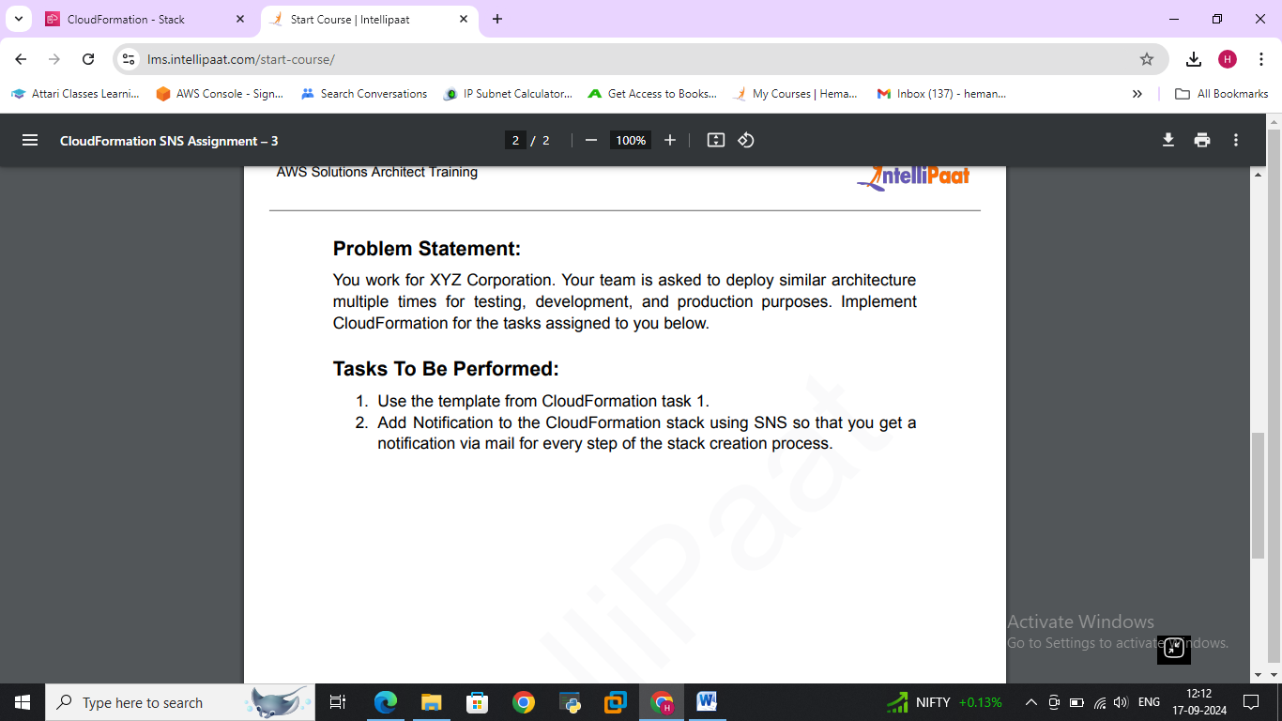

**>>Created SNS topic for S3 Templet**

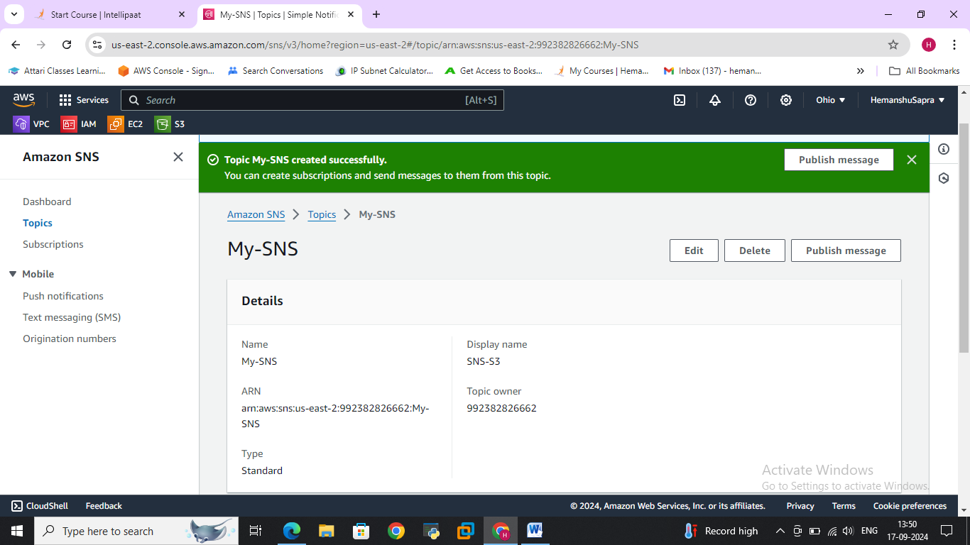

**>>Created Suscription and confirmed via E-Mail**

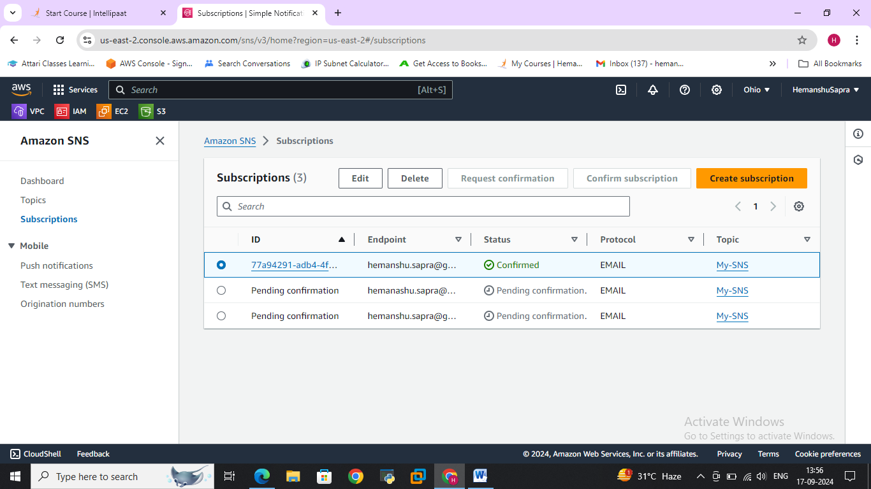

**>>Created CF Templet and validated**

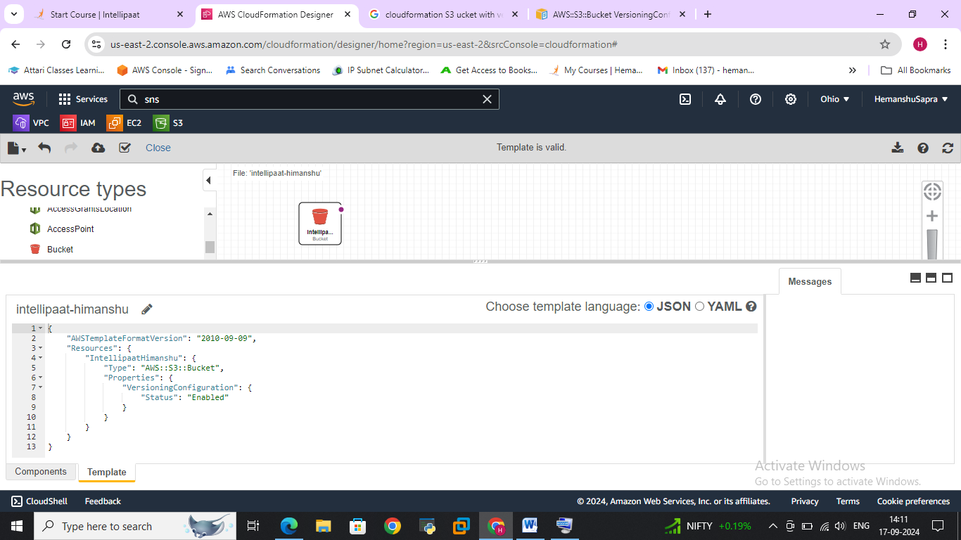

**>>Added SNS Topic while creating Stack from CF**

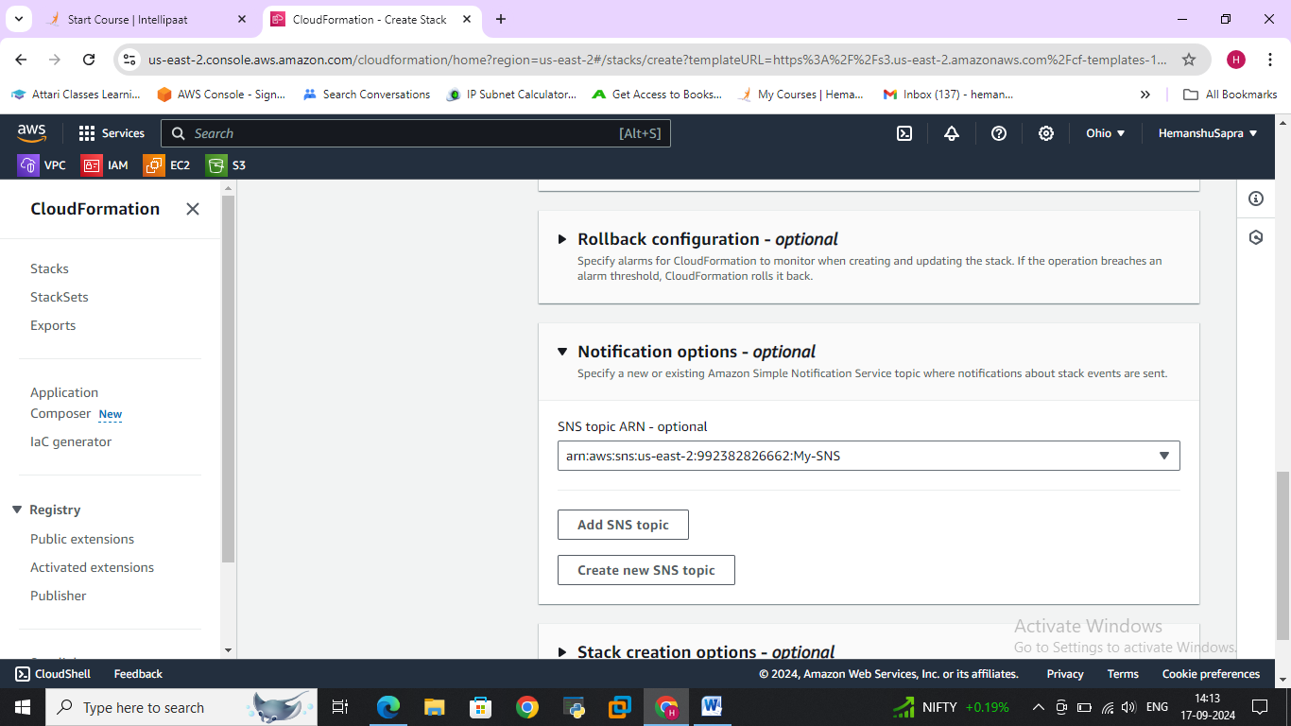

**>>Mail Received for CF stack in progress**

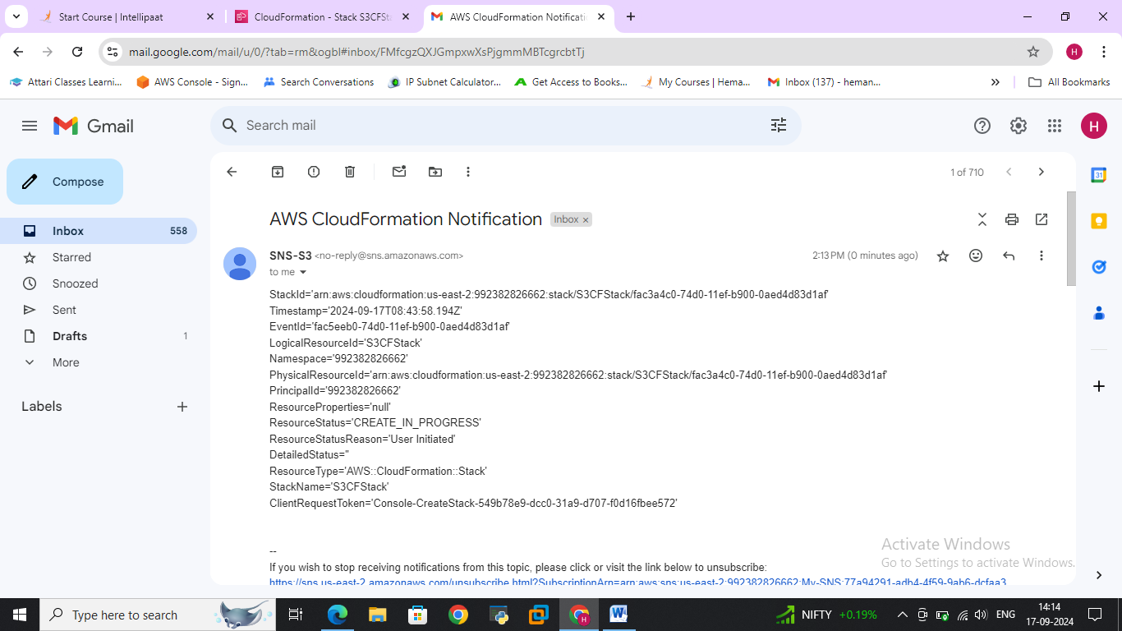

**>>Stack successfully created**

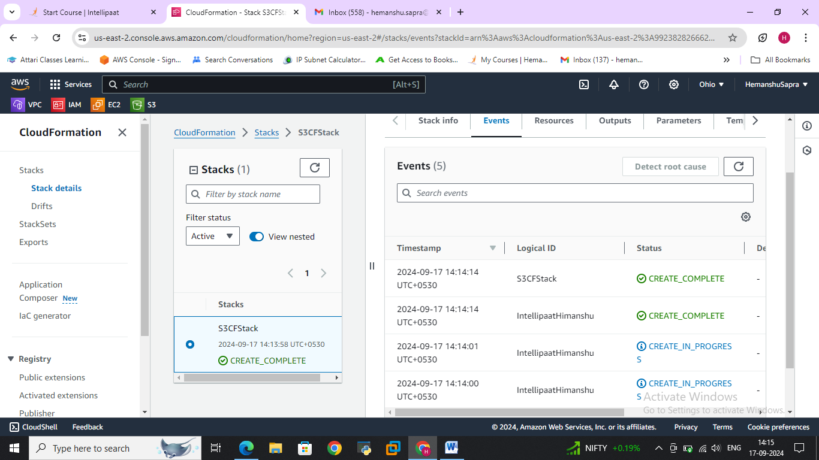

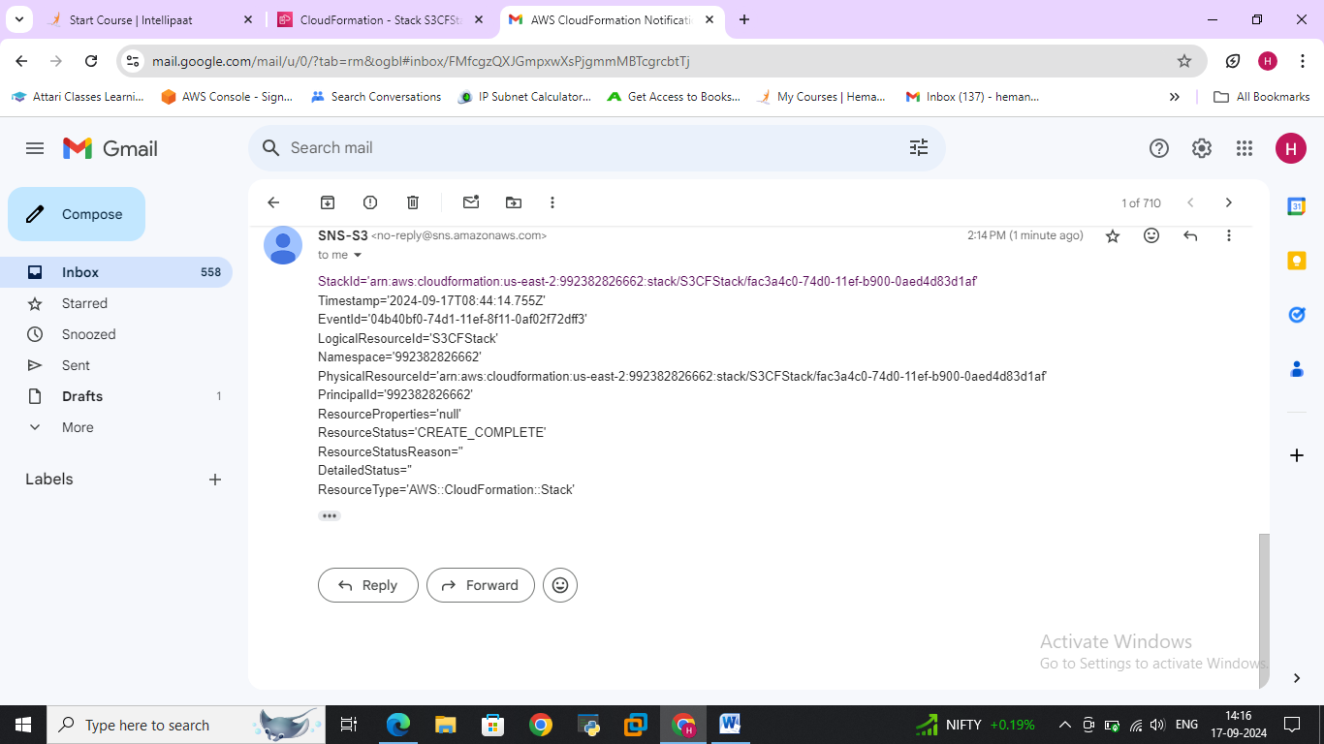

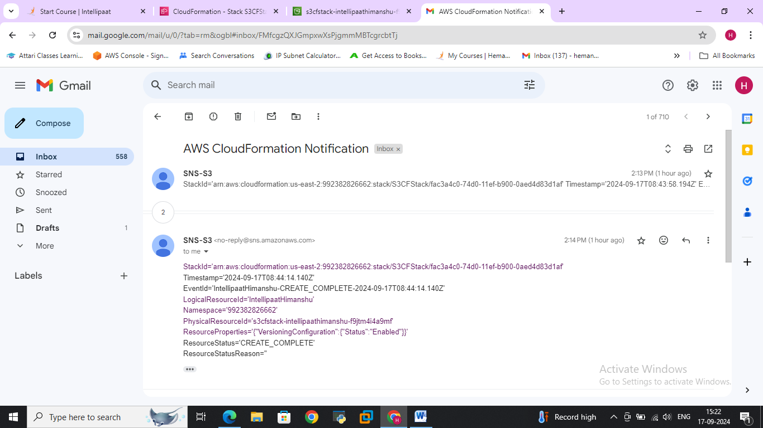

**SQS-And-SES-Assignment**

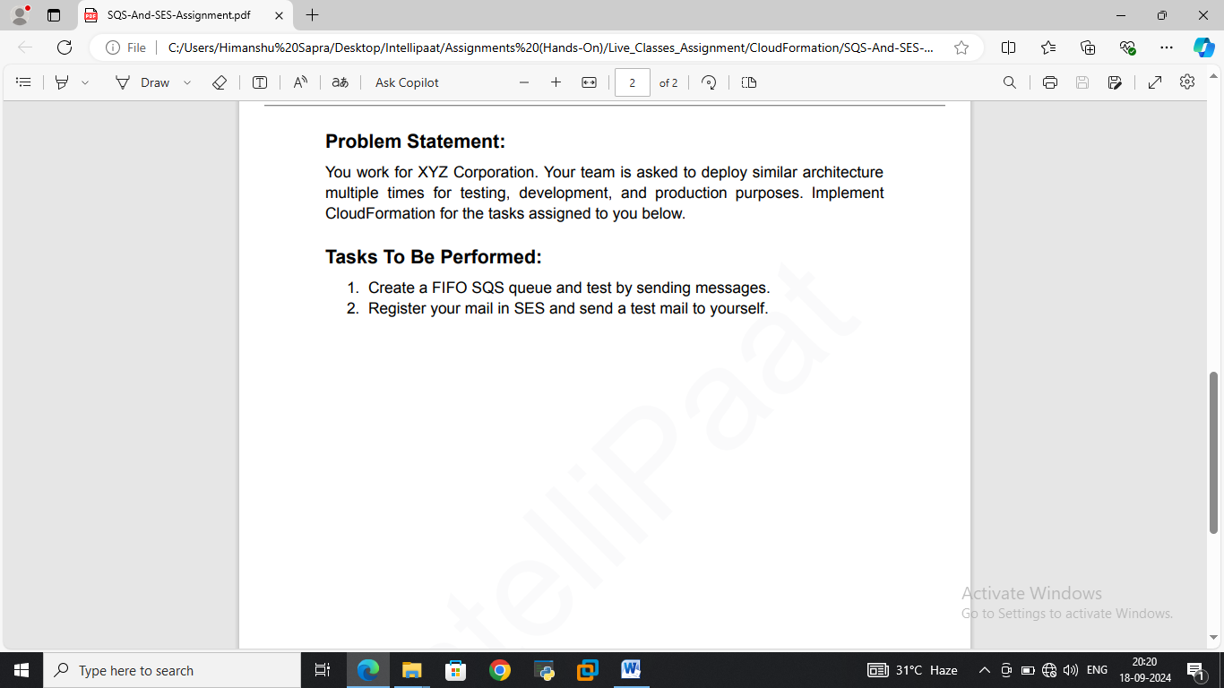

**>>Identity created and verified**

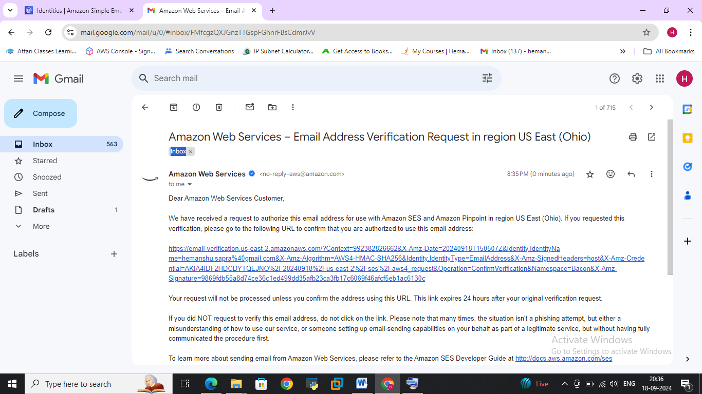

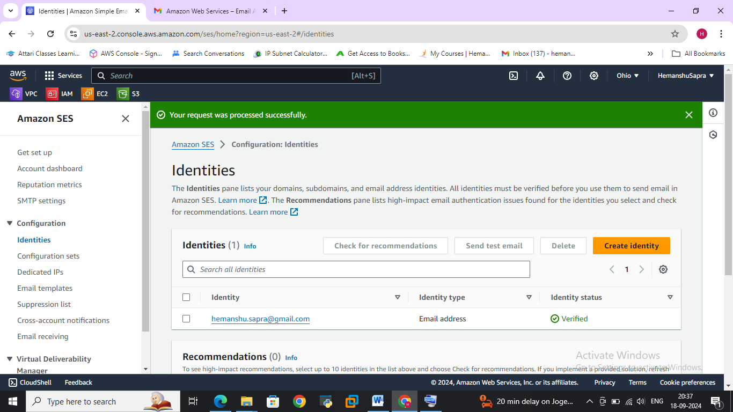

**>>received test mail from SES configuration**

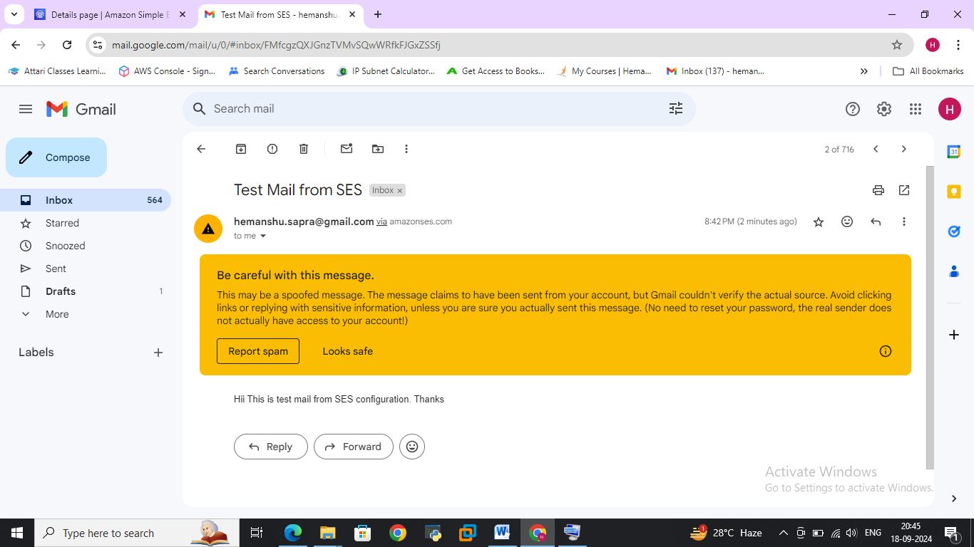

**Task**

**>>Created FIFO SQS Queue**

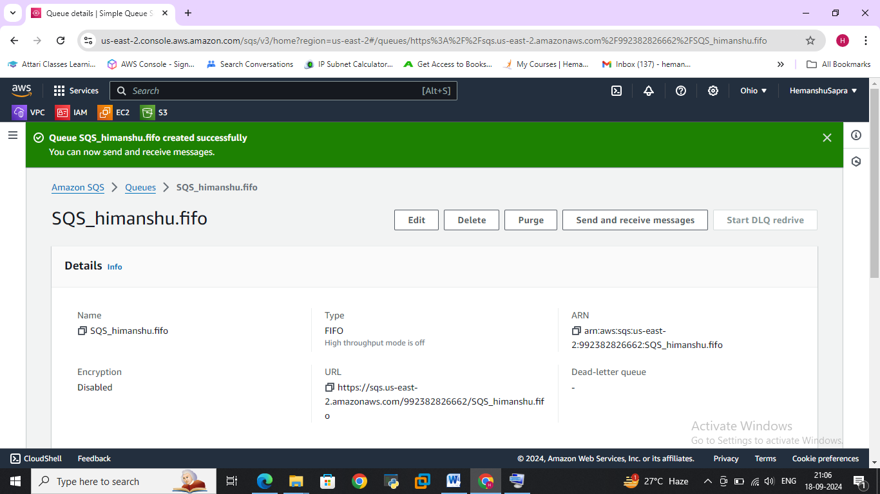

**>>receiving messages**

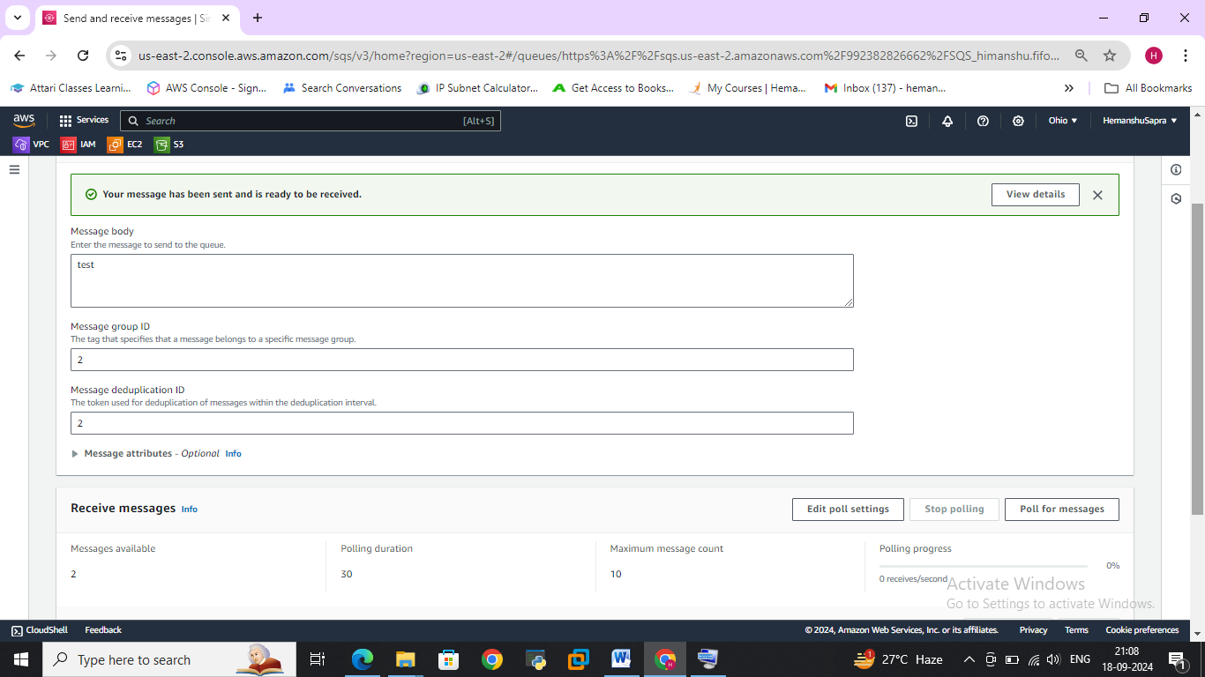

**>>We can read messages after polling**

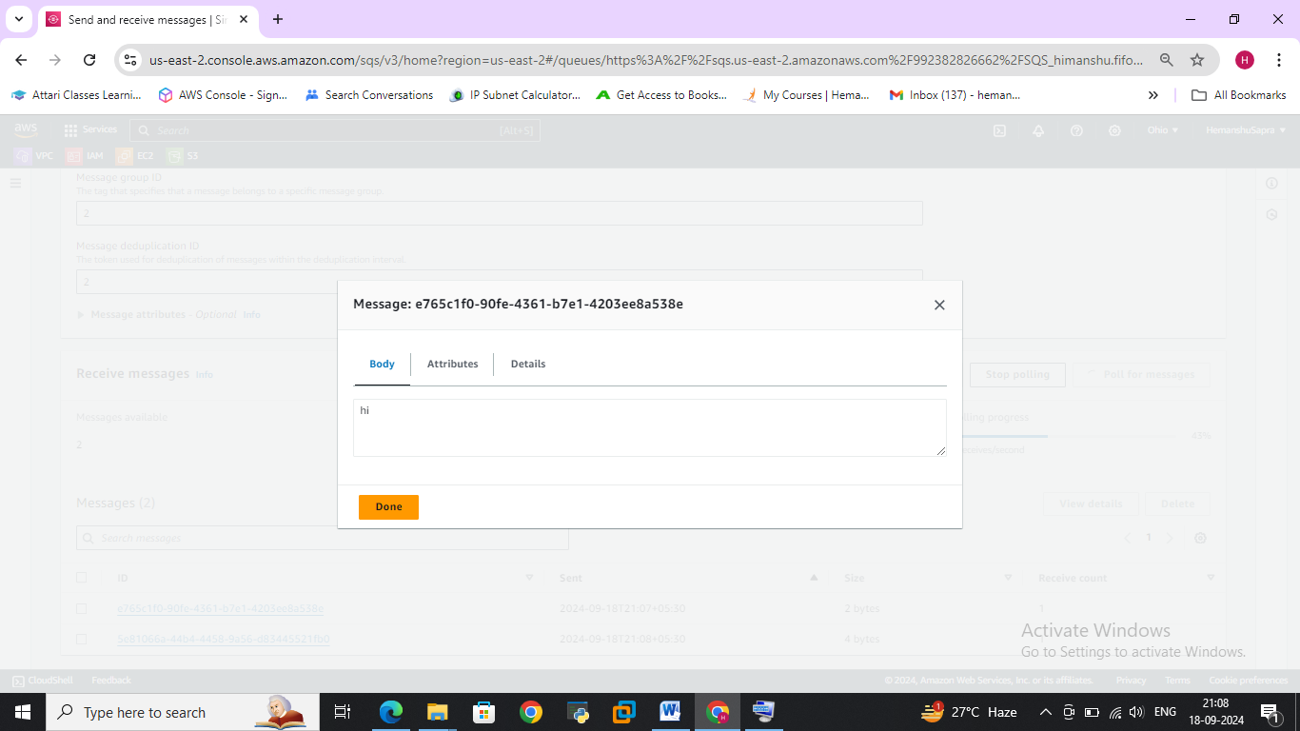

**Case Study-Multi Tier Architecture**

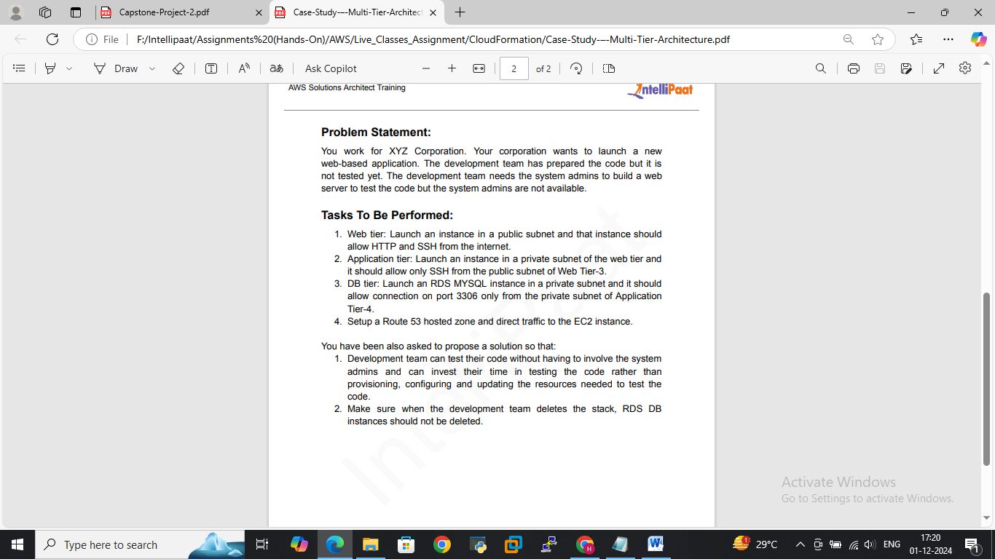

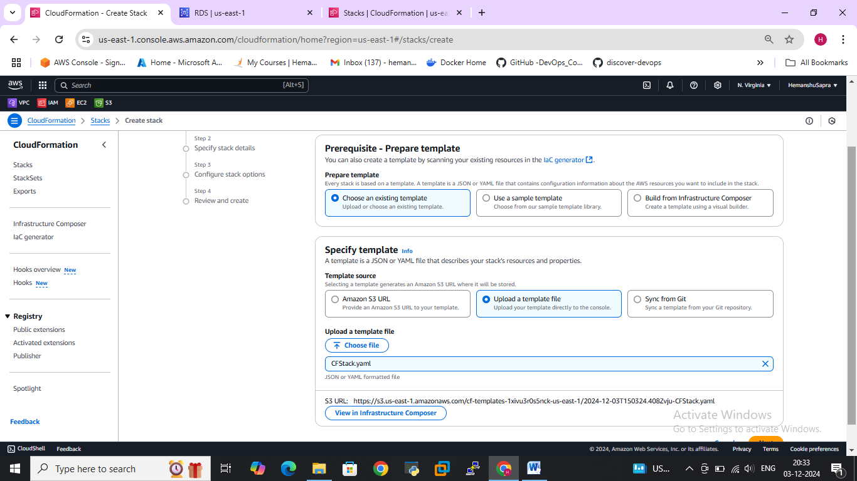

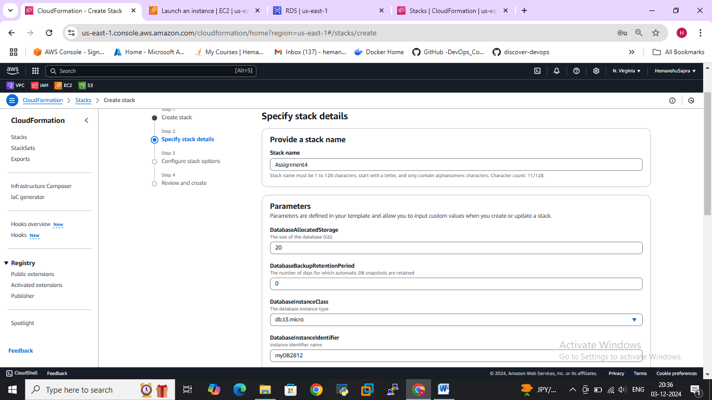

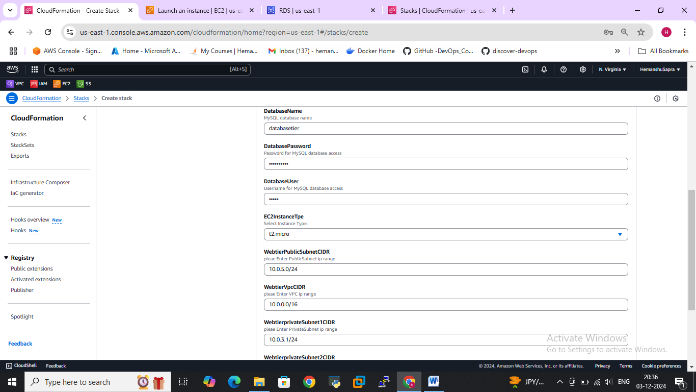

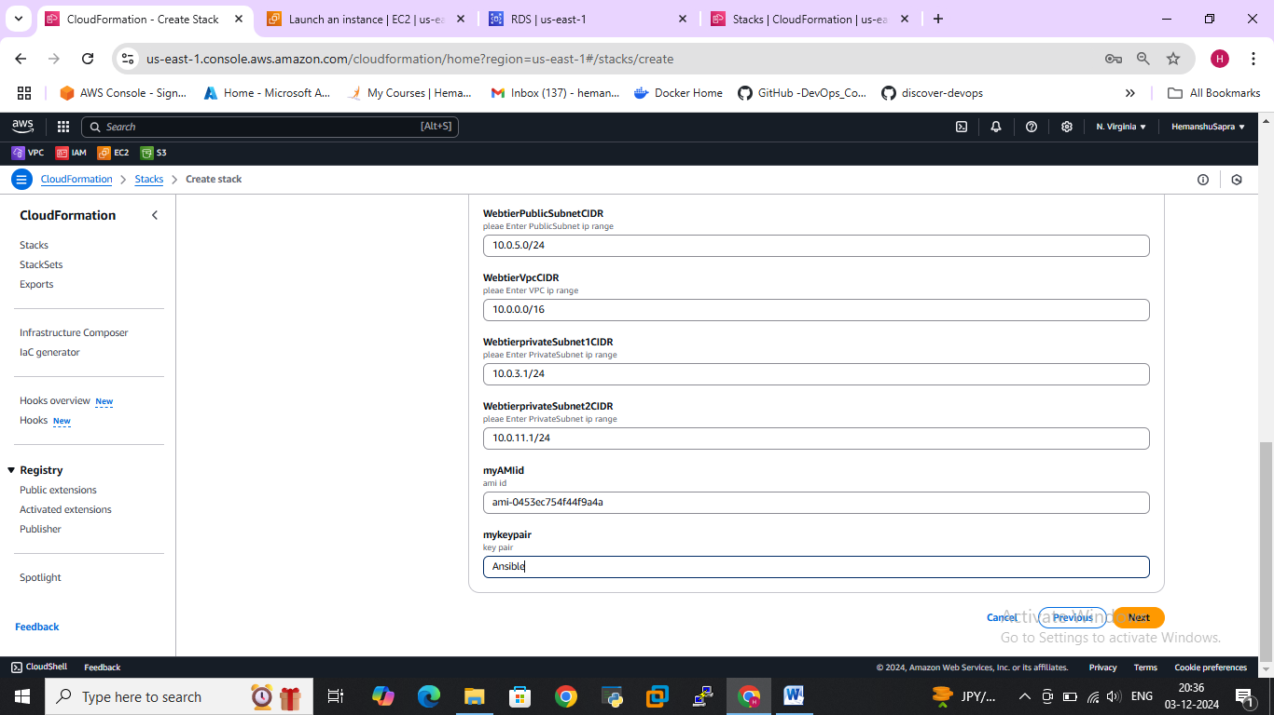

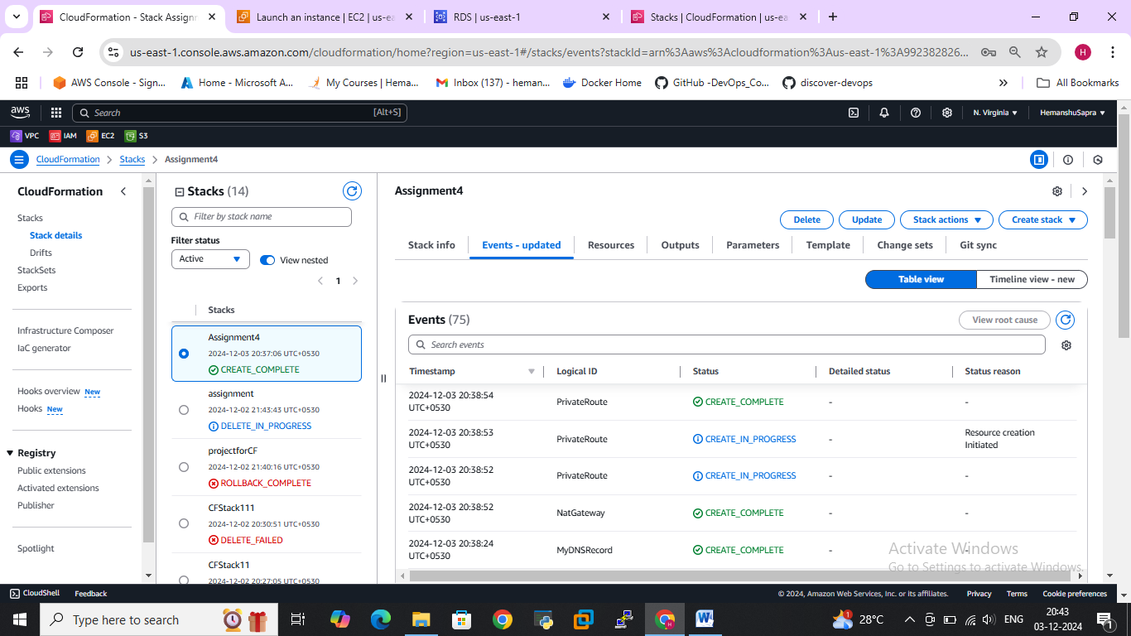

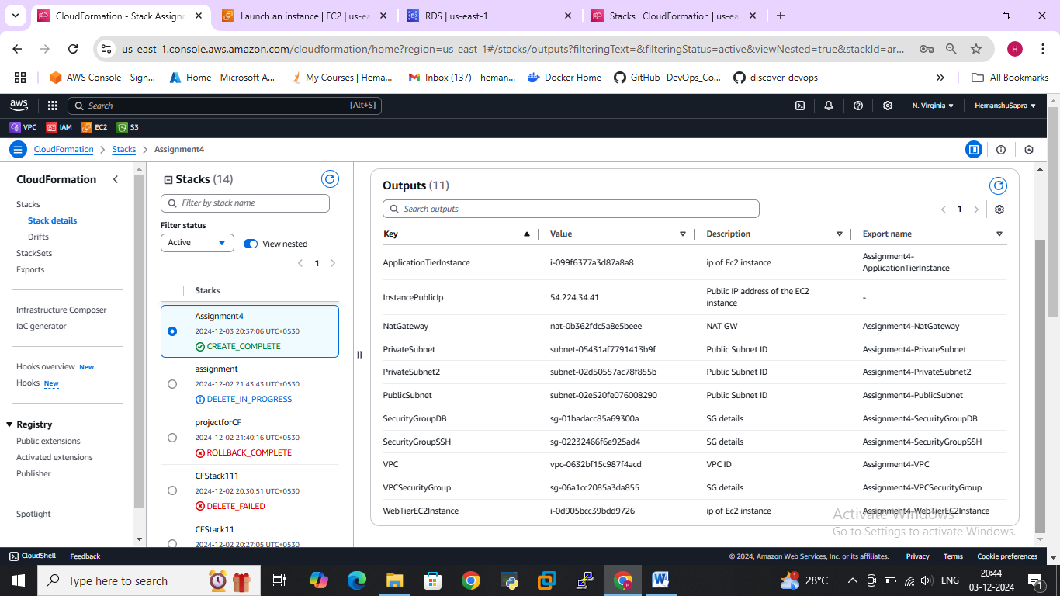



1. >>> Web tier: Launch an instance in a public subnet and that instance should allow HTTP and SSH from the internet.

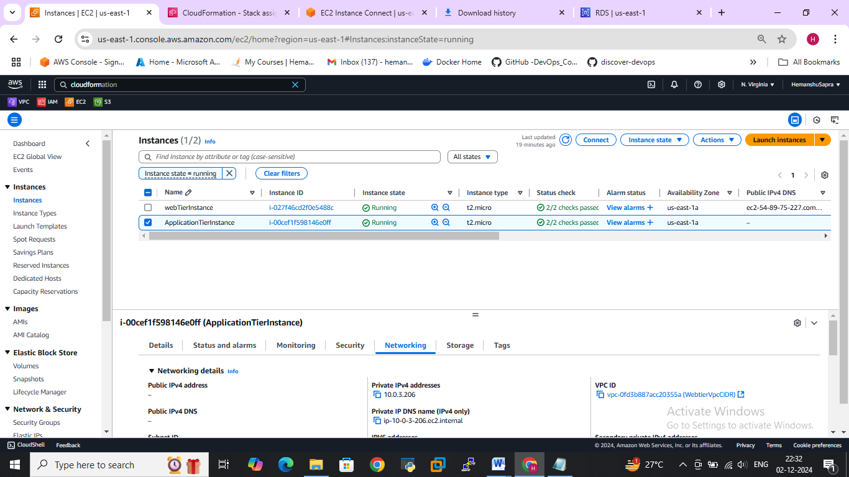

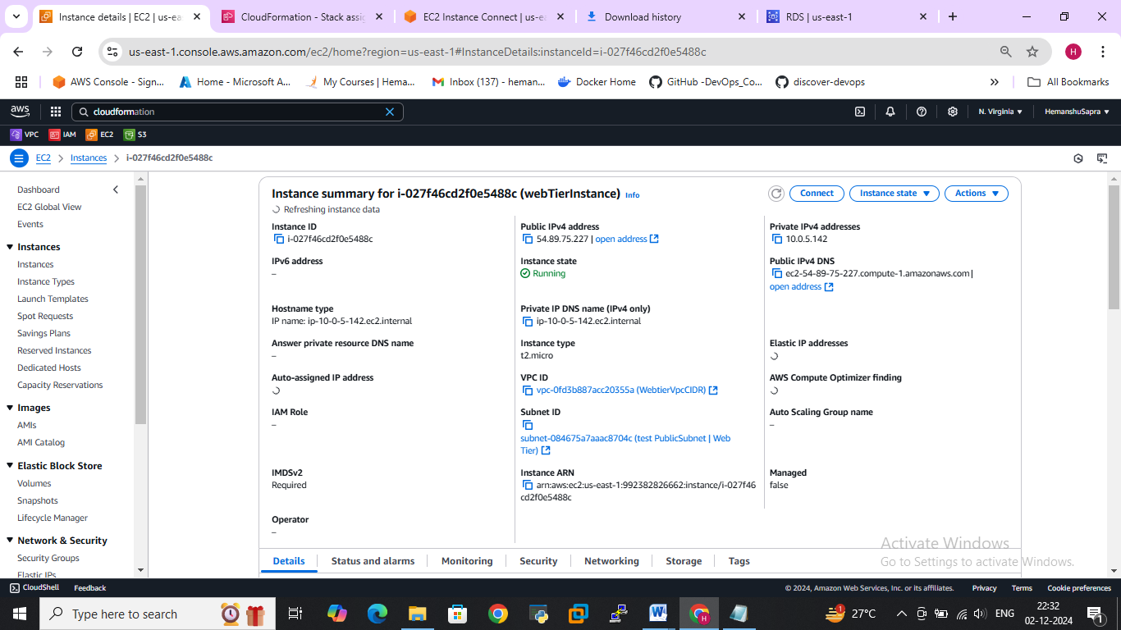

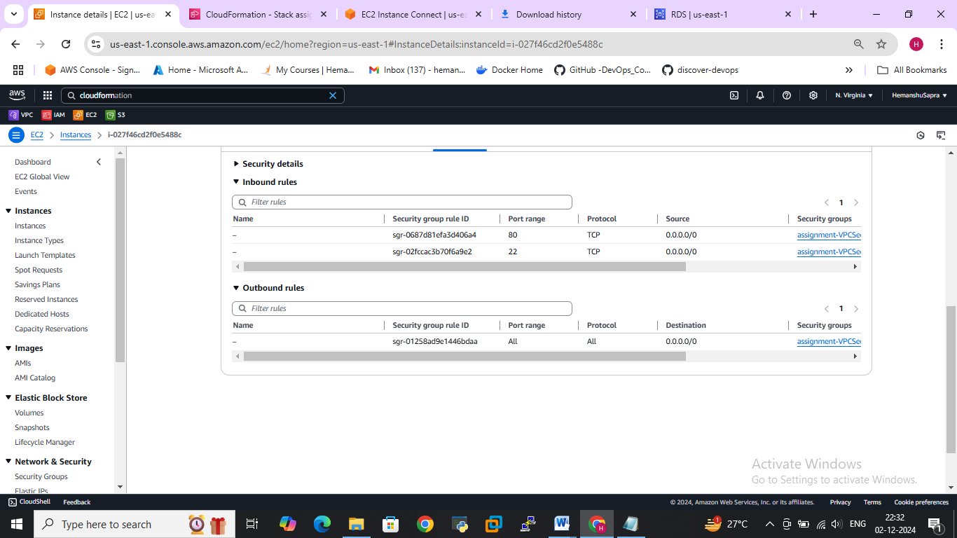

**Subnet**

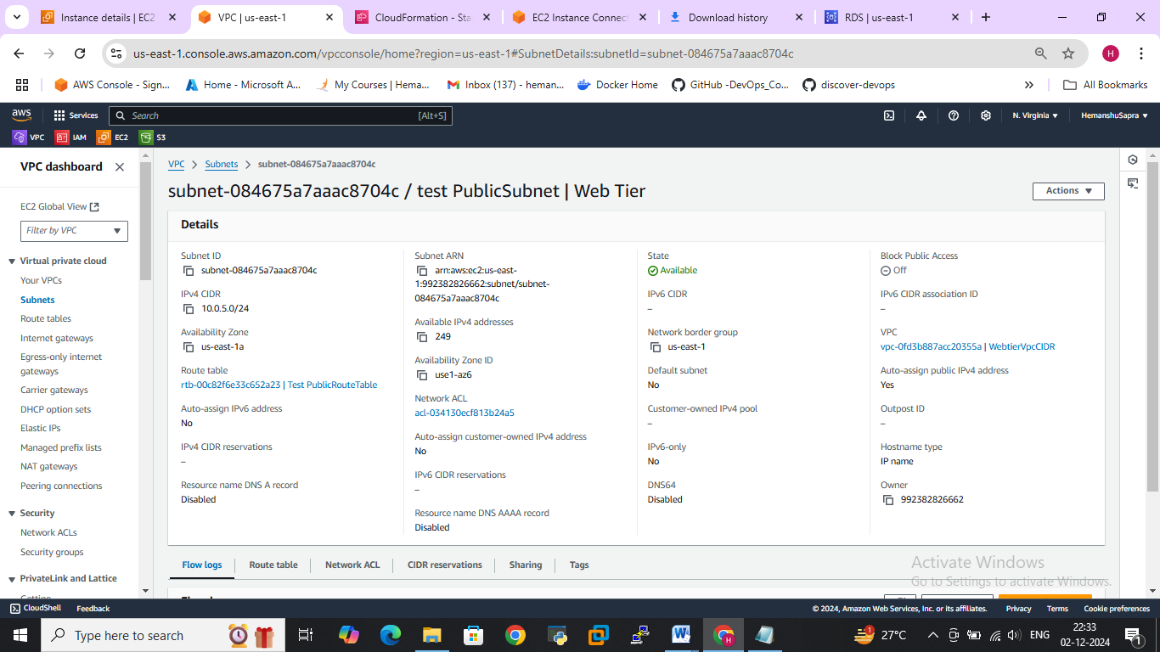

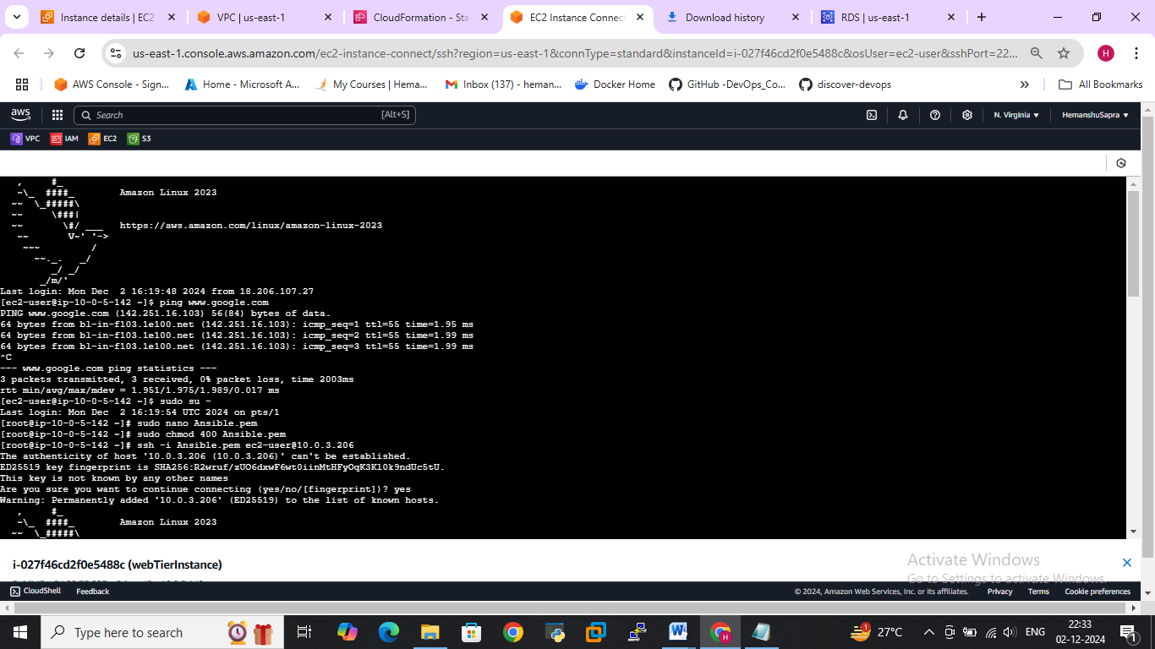

**Application tier: Launch an instance in a private subnet of the web tier and it should allow only SSH from the public subnet of Web Tier-3.**

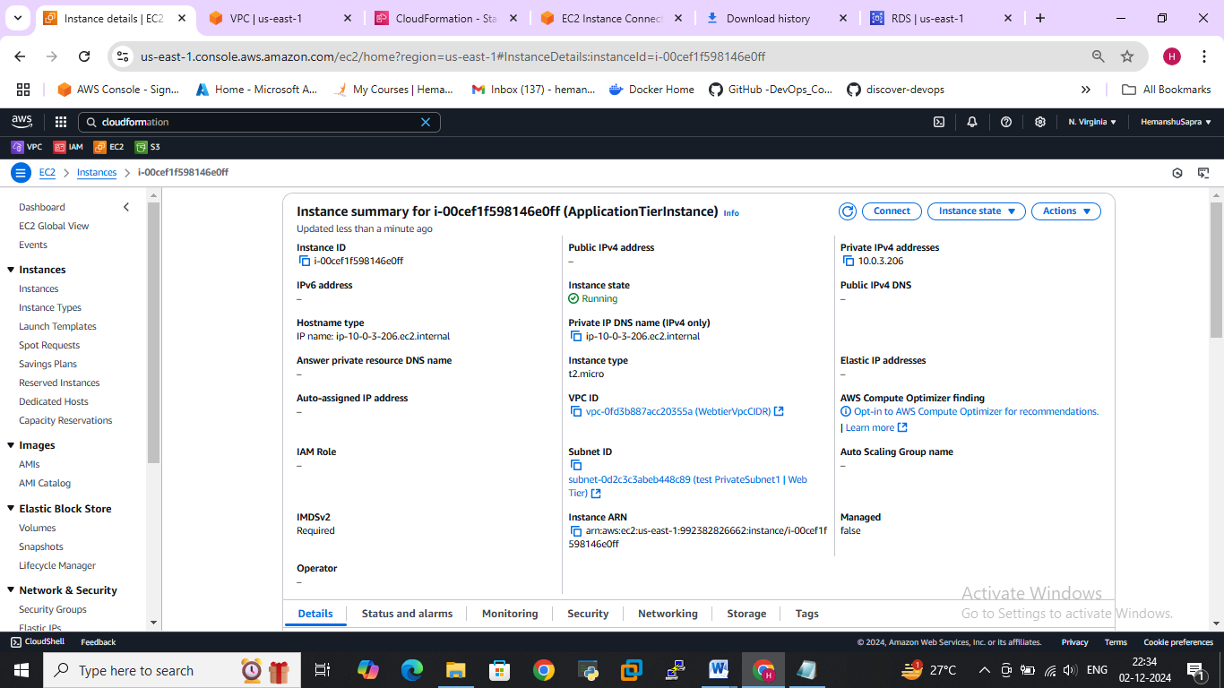

Connected to application instance via ssh through web instance

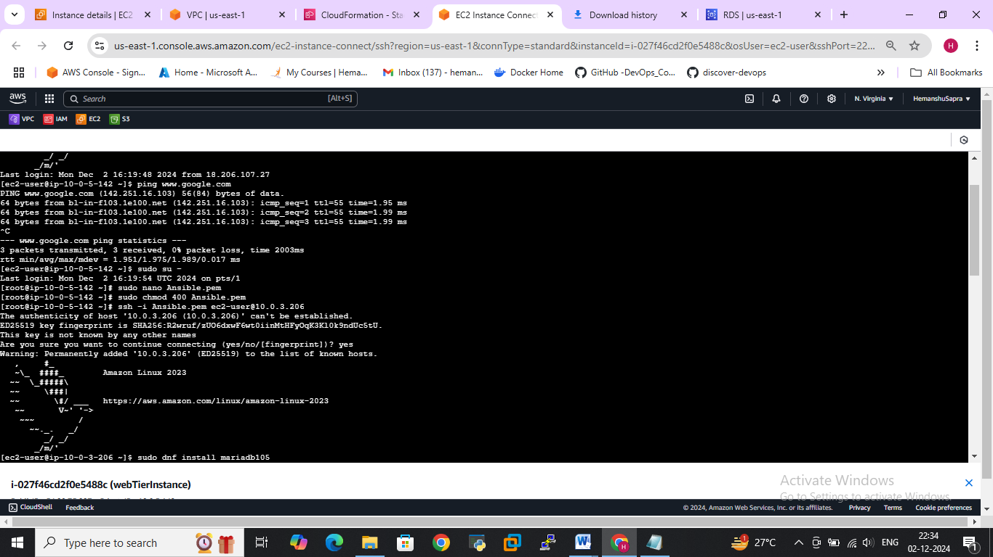

**DB tier: Launch an RDS MYSQL instance in a private subnet and it should allow connection on port 3306 only from the private subnet of Application Tier-4.**

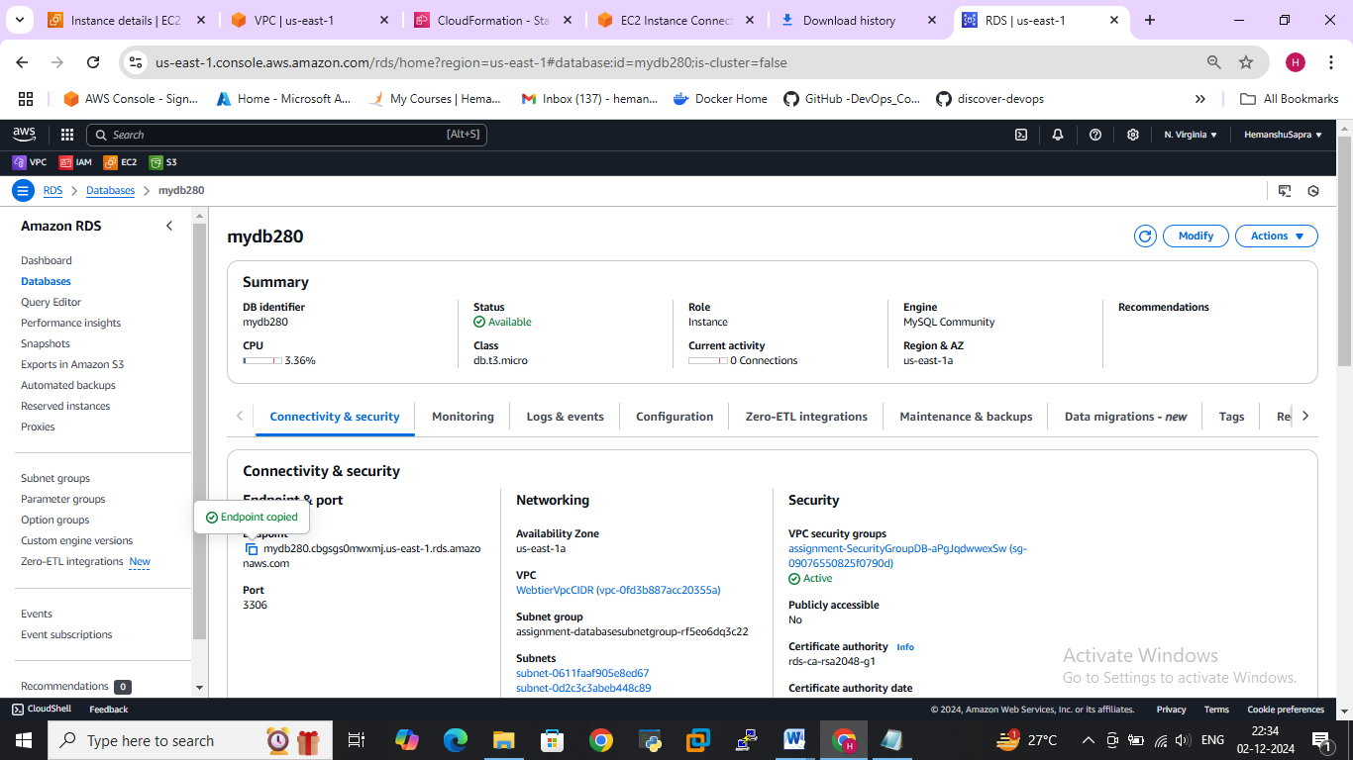

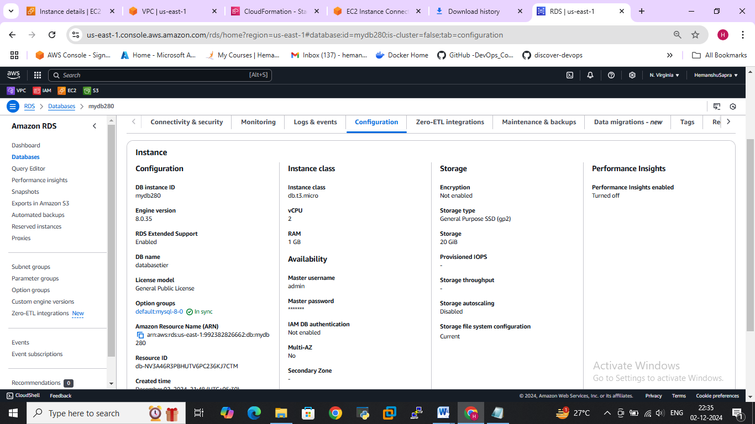

**>>>** Connect db instance via pvt application instance

To connect db instance we need to install mysql Clint in pvt instance

To install > sudo dnf install mariadb105

To connect > mysql -h (dbendpoint) -P 3306 -u mymasteruser –p

